The following plots correspond to Part 3 of the HW. The first plot displays trajectories passing through (3.3,1.1), (4,2), and (0,0) at t = 0 for both u = 1 and u = -1 for each initial condition. From this we see that trajectories with the same u value do not intersect one another, which is expected. We can also see that we are unable to reach the desired final state, (0,0), with a single switch, as the curves corresponding to the initial and final states do not intersect one another. The second plot indicates that it may be possible in two switches to get from the initial state curve to the final state curve, though we find that that is not the case. Instead, we require four switches to get from the initial state trajectory to the final state trajectory. The third and final plot displays the optimal four-switch trajectory found using the *fsolve* function in MATLAB, using the default algorithm and with the initial conditions *x0 = [(pi-1)/4, 2.5*pi-1, .4, 2.3, .33, 1.5, .2, .9, .2, .5]*. These correspond, respectively, to the guessed first switch and total time, and the guessed coefficients for the 2nd, 3rd, 4th, and final state curves. For this case, the initial u value was -1; a four-switch solution was not found for the u = 1 case. Also, as implied by showing a four-switch solution, no solutions were found for the two- and three-switch cases. The solution obtained for the four-switch, in the same format as *x0* above, was *[0.1323, 5.4369, 0.2884, 2.8348, 0.0269, 1.8696, -0.2347, 0.9045, -0.4963, -0.0607]*.

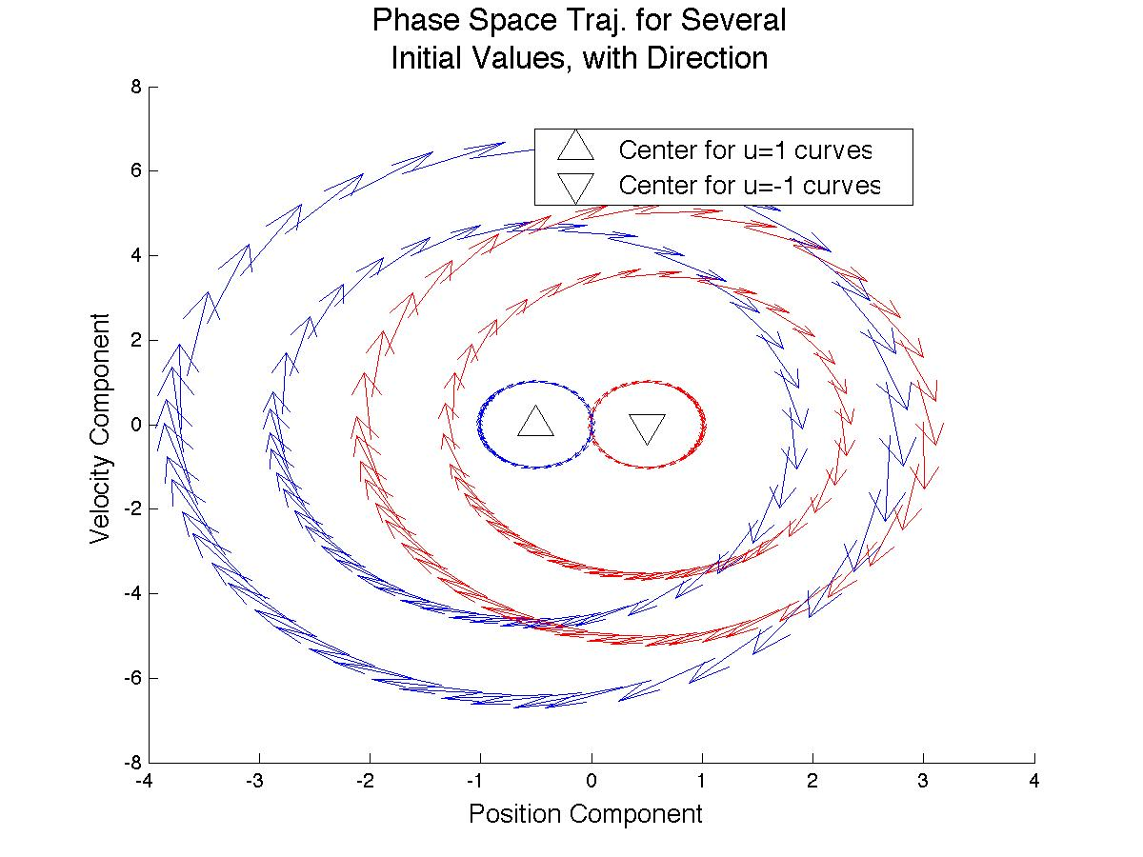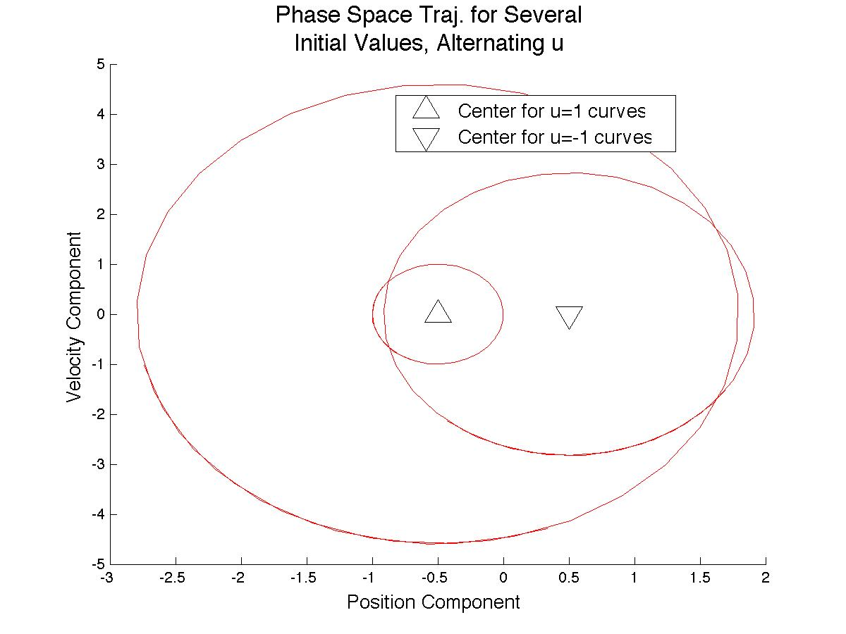

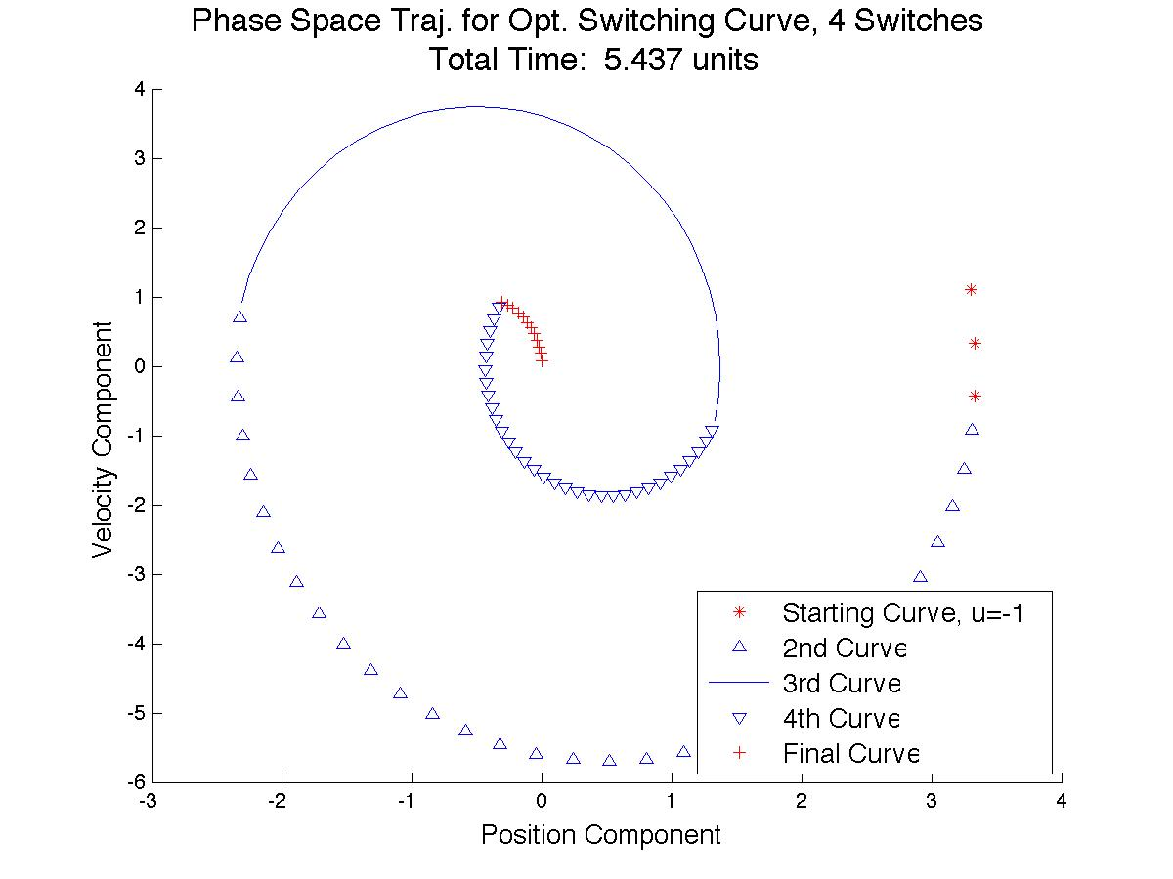***Code:***

function F = myfun(x)

% x0 = [(pi+0.1)/4; (3*pi+0.1)/4; -2; -1];

% options=optimset('MaxFunEvals', 5000, 'TolFun',1e-8, 'TolX', 1e-8, 'MaxIter', 5000);

% [xSol,fval] = fsolve(@myfun,x0,options)

u = 1;

% uf =1;

xf = inline('(k/2)*sin(2*t) + (j - .5*u)*cos(2*t) + .5*u', 't', 'u', 'k', 'j');

vf = inline('k*cos(2*t) - (2*j - u)*sin(2*t)', 't', 'u','k','j');

x1f = inline('k*sin(2*t) + j*cos(2*t) + .5*u', 't', 'u', 'k', 'j');

v1f= inline('2*k*cos(2*t) - 2*j*sin(2*t)', 't', 'u','k','j');

% 4-switch

F = [xf(x(1),u,1.1,3.3) - x1f(x(1),-u,x(3),x(4));...

vf(x(1),u,1.1,3.3) - v1f(x(1),-u,x(3),x(4));...

x1f(x(1)+pi/2,-u,x(3),x(4)) - x1f(x(1)+pi/2,u,x(5),x(6));...

v1f(x(1)+pi/2,-u,x(3),x(4)) - v1f(x(1)+pi/2,u,x(5),x(6));...

x1f(x(1)+pi,u,x(5),x(6)) - x1f(x(1)+pi,-u,x(7),x(8));...

v1f(x(1)+pi,u,x(5),x(6)) - v1f(x(1)+pi,-u,x(7),x(8));...

x1f(x(1)+(3/2)*pi,-u,x(7),x(8)) - x1f(x(1)+(3/2)*pi,u,x(9),x(10));...

v1f(x(1)+(3/2)*pi,-u,x(7),x(8)) - v1f(x(1)+(3/2)*pi,u,x(9),x(10));...

x1f(x(2),u,x(9),x(10));...

v1f(x(2),u,x(9),x(10))];

% x0 = [(pi-1)/4; 2.5*pi-1; .4; 2.3; .33; 1.5; .25; .9; .2; .5];

% options=optimset('MaxFunEvals', 5000, 'TolFun',1e-8, 'TolX', 1e-8,

% 'MaxIter', 5000);

% Plot 4 Switch

figure

title({'\fontsize{16} Phase Space Traj. for Opt. Switching Curve, 4 Switches';...

['Total Time: ' num2str((round(x(2)*1000)/1000)) ' units']});

xlabel('\fontsize{13} Position Component');

ylabel('\fontsize{13} Velocity Component');

hold on

plot(xf(0:y:x(1),u, 1.1,3.3),vf(0:y:x(1),u,1.1,3.3), 'r*')

plot(x1f(x(1):y:x(1)+pi/2,-u,x(3),x(4)),v1f(x(1):y:x(1)+pi/2,-u,x(3),x(4)), 'b^')

plot(x1f(x(1)+pi/2:y:x(1)+pi,u,x(5),x(6)),v1f(x(1)+pi/2:y:x(1)+pi,u,x(5),x(6)), 'b-')

plot(x1f(x(1)+pi:y:x(1)+(3/2)*pi,-u,x(7),x(8)),v1f(x(1)+pi:y:x(1)+(3/2)*pi,-u,x(7),x(8)), 'bv')

plot(x1f(x(1)+(3/2)*pi:y:x(2),u,x(9),x(10)),v1f(x(1)+(3/2)*pi:y:x(2),u,x(9),x(10)), 'r+')

legend('\fontsize{13} Starting Curve, u=-1',...

'\fontsize{13} 2nd Curve',...

'\fontsize{13} 3rd Curve',...

'\fontsize{13} 4th Curve',...

'\fontsize{13} Final Curve',...

'Location','SouthEast');

hold off

function BasePlot(xin,k)

x = xin';

% xin = [3.3,1.1;4,2;0,0];

xf = inline('(k/2)*sin(2*t) + (j - .5*u)*cos(2*t) + .5*u', 't', 'u', 'k', 'j');

vf = inline('k*cos(2*t) - (2*j - u)*sin(2*t)', 't', 'u','k','j');

x1f = inline('k*sin(2*t) + j*cos(2*t) + .5*u', 't', 'u', 'k', 'j');

v1f= inline('2*k*cos(2*t) - 2*j*sin(2*t)', 't', 'u','k','j');

xdot = vf;

vdot = inline('-4*((k/2)*sin(2*t) + (j - .5*u)*cos(2*t) +.5*u) + 2*u', 't', 'u', 'k', 'j');

x1dot = v1f;

v1dot = inline('-4*(k*sin(2*t) + j*cos(2*t) +.5*u) + 2*u', 't', 'u', 'k', 'j');

figure

title({'\fontsize{16} Phase Space Traj. for Several';...

'\fontsize{16} Initial Values, with Direction'});

xlabel('\fontsize{13} Position Component');

ylabel('\fontsize{13} Velocity Component');

hold on

plot(-.5,0,'k^','MarkerSize',16)

plot(0.5,0,'kv','MarkerSize',16)

for ind = 1:k

quiver(xf(1:.1:5,1,x(1,ind),x(2,ind)),vf(1:.1:5,1,x(1,ind),x(2,ind)),...

xdot(1:.1:5,1,x(1,ind),x(2,ind)),vdot(1:.1:5,1,x(1,ind),x(2,ind)),'r-')

quiver(xf(1:.1:5,-1, x(1,ind),x(2,ind)),vf(1:.1:5,-1,x(1,ind),x(2,ind)),...

xdot(1:.1:5,-1,x(1,ind),x(2,ind)),vdot(1:.1:5,-1,x(1,ind),x(2,ind)),'b-')

end

legend('\fontsize{13} Center for u=1 curves',...

'\fontsize{13} Center for u=-1 urves',...

'Location','Best');

hold off